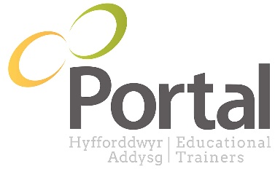

Application Guidance

- Please read these guidelines carefully before completing your application form.

- If you are applying for more than one vacancy, please fill in a different application form for each vacancy.

- The application form plays an important part in our selection process. It is vital that you fill it in as fully and accurately as possible.

- Please only include your CV (curriculum vitae) as supporting evidence for your application form and not in place of completing any sections of the form.

- Please make sure you read the Job Description for the vacancy you are applying for fully before you complete the application form. This will help you decide if you are a suitable applicant for the job.

- If it is not possible to complete the electronic application form, we are happy to receive a written version posted to:
HR Department
Portal Training
Ocean Park House
East Tyndall Street
Cardiff
CF24 5ET
Please complete this in black ink only, making sure that the information is clear and legible.

- ADDITIONAL INFORMATION. We will pay attention to how well your experience and skills meet the criteria of the Job Description. You should, therefore, make clear how you meet these criteria. If you feel you need more space in any section of the application form, please use extra sheets of paper putting your name and the job you are applying for at the top of each sheet.

- To apply for a vacancy, you must be eligible to work in the UK.

- PORTAL’S CORE VALUES. This is an essential part of the application form as Portal recruit on attitudes as well as on skills and experience.

