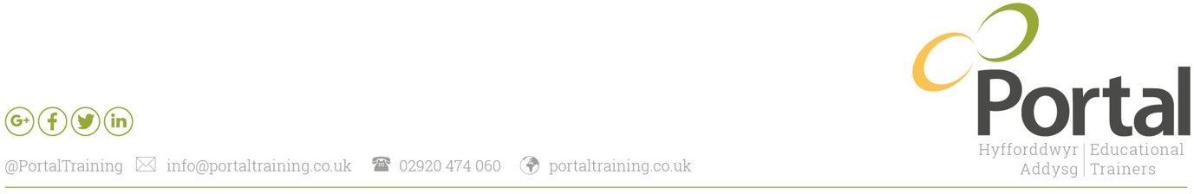
Job Description: Children’s Care, Play and Learning & Development Assessor.

Line Manager/responsible to: Contracts Manager and allocated Internal Quality Assurer (IQA)

Responsible for: NA

Salary banding: £21,000 to £25,000 PA, PLUS additional £500 for delivery via Welsh language.

Summary of Role

To support an active caseload of up to 37 learners to achieve all required framework components through a mentoring, facilitative approach in a timely and efficient manner.
To provide an excellent level of customer service to all learners, mentors, employers and other relevant stakeholders.
Actively engage with learners on a monthly basis to review progress, assess and feedback on learner work and plan assessment activities.
Ensure work practices and performance conforms to Welsh Government, Lead Provider and company specification.
Embrace Continuous Professional Development in order to develop route knowledge and competence by research and involvement in learning and development opportunities.
Positively engage with Portal Training’s Quality Assurance department to ensure outstanding delivery standards and support company evaluative activities.

Delivery
- Deliver Induction sessions to provide an overview of the Framework which includes Children’s Care, Play and Learning & Development QCF Levels 2 & 3 and Essential Skills controlled tasks and assessments in Application of Number, Communication and Digital Literacy.
- Support learners to progress through the learning journey through effective assessment planning, feedback and regular learner interaction.
- Provide constructive feedback to learners on an ongoing bases to ensure learners progress through their programme in a timely manner and to ensure clarity and understanding for all parties.
- Communicate progress and achievement of learner to the mentor and/or employer consistently throughout the programme.
- Collaborate and communicate with ESW IQA to ensure all ES Controlled Tasks and Confirmatory Tests are conducted in a professional manner.
- Ensure that WEST initial assessments are referred to in order to identify areas of development for Numeracy, Literacy and Digital Literacy.
- Complete Individual Assessment and Learning Plans (IALP) with all learners to ensure effective and appropriate support is provided throughout the learner journey and progress is recorded.
- Complete reviews monthly ensuring that the Learner and mentor confirm that they are aware of the progress being made and they are clear on the work being planned in the timescales agreed.
- Ensure leaner work is assessed to ensure IQA sampling can be carried out at Formative, Ongoing and Summative stage.
- Address all IQA actions by the date agree between IQA and assessor.

Performance and Conformance
- Monitor Learner reviews with actions reports and ensure actions are completed and submitted within 1 month of the review date.
- Monitor your learner provisional achievers list to ensure no learners are over 12 weeks from their termination dates.
- Support and effectively engage with learners to achieve attainment rates of 90%.
- Ensure learners complete on or before their expected end date achieving a minimum timely achievement rate of 85%.
- Complete reviews with learners monthly (maximum every 61 days) ensuring compliance to Welsh Government Programme Specification, Lead Provider expectations and internal practices.
- Maintain regular contact with suspended learners ensuring that the Conformance Officer is kept up to date and all communication and evidence is recorded on Vision.
- Submit ELI information on or before the required review date.
- Complete Health & Safety monitoring forms as directed by Portal Conformance Officer within a timely manner.
- Ensure that learner Centre files are always regularly audited and audit ready.
- Ensure that suspended learners are brought back on or before their expected return date or suitable action is taken.
- Complete all Welsh Government documentation fully to an excellent standard.

Quality Assurance
- Compulsory attendance to all standardisation meetings to ensure effective and consistent assessment decisions.
- Positively engage with the IQA Team to ensure outstanding standards of delivery.
- Complete all IQA action points by the agreed date.
- Provide any information requested by Director of Quality, Qualifications Quality Manager and IQA team in preparation for any visits from Awarding Organisations, ESTYN or lead provider audits.
- Maintain positive, effective working relationships with your IQA and the wider Quality Team to ensure Continuous improvement in relation to the quality of the delivery of all qualifications.
- To adhere to the Code of Professional Conduct and Practice for Registrants with the Education Workforce Council at all times.
- To maintain the Professional Standards for Work Based Learning Practitioners in Wales regardless of delivery area.

Learner and Employer Engagement
- Communicate regularly and professionally with learners and employers to maintain good relationships and engagement in the learning process.
- Develop links with customers to promote new business as appropriate.
- Act as a conduit between employers and Portal ensuring that all business leads are referred to the appropriate team member.

General Duties
- Update job knowledge by participating in educational opportunities; reading trade publications and attending networking events.
- Take part in any project work deemed necessary by Portal Training’s senior management team.
- Fully engage with and adhere to Portal Training’s company values.
- Embrace Portal Training’s strategies, polices and processes.
- Ensure that all your practices adhere to information security policies, procedures and legislation.
- Work as a team to ensure continuous quality improvements supporting the company’s journey to excellence.
- Keep outlook calendars up to date at all times.

Key Responsibilities: The above duties are not an exhaustive list and should be viewed as guidance. Your line manager or Portal’s Senior Management team may ask that you take part in additional duties in order to fully utilise your experience, skills and knowledge.

Personal Qualities
- A proven track record in working within similar roles.
- Excellent communication skills both written and verbal.
- A highly self-motivated individual with a positive ‘can do’ attitude.
- Good attention to detail.
- Good time management skills.
- Customer or Client Service Orientation.
- Good presentation skills.
- An excellent relationship builder.
- Good negotiation skills.

Essential Experience and Skills
- A minimum of 3 years’ experience of working within a childcare setting.
- Obtains a qualification in childcare (for children ranging between ages 0 -19) at level 3 minimum or equivalent.
- Excellent Microsoft Office skills.
- A good level of Maths and English.
- Fluent Welsh speaker.
- Holds a full U.K driving licence.

Desirable Experience and Skills
- Holds assessor qualification (E.G. TAQA/A1/D32).
- Holds internal verifier qualification (E.g. TAQA, V1).
- Experience of assessing vocational based qualifications/assessment practice.
- Experience of Work Based Learning.
- Obtains a qualification in childcare (for children ranging between ages 0 -19) at level 5 or equivalent.
- Experience of in working with different electronic platforms such as Learning Assistant, One File or Moodle.

Key Performance Indicators
Measure | QA Activity | Performance Indicators
Core Values | Demonstrated Core Values | (RAG) Green
Delivery | All learner work to be marked within one month of being uploaded to Learning Assistant | 100%
Performance & Conformance | Learner attainment rate of 90% | 100%
 | Timely achievement rate of 85% | 100%
 | Achieve all relevant ES qualifications, equal to or below 10 months from learner start date | 100%

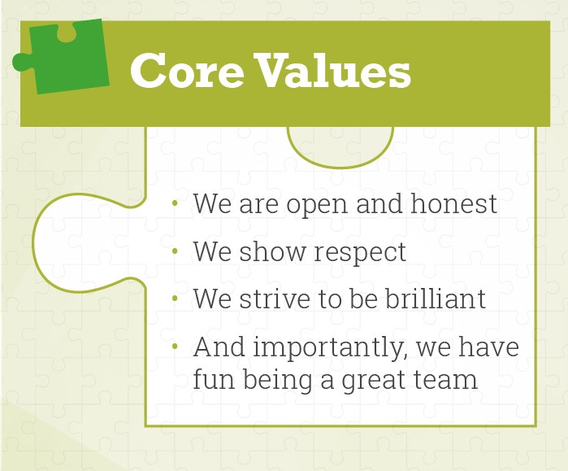
Portal Values

